Case Study: E-commerce Checkout Flow

User Story:
As a | Registered user of http://mywebsite.com
I want | To complete my purchase quickly and securely
So that | I can receive my products without unnecessary delays
Acceptance Criteria | - On http://mywebsite.com, system shall initiate checkout process as per Appendix 1: Checkout Process Flow.  - System shall display the Cart Page with product details; quantity, price, total, and a “Checkout” button (refer Appendix 2: Cart Page Wireframe and Appendix 3: Cart Page Data Table).  - On click of Checkout, system shall navigate the user to the Shipping Address Page (refer Appendix 4: Shipping Address Wireframe and Appendix 5: Shipping Address Data Table).  - System shall allow the user to enter shipping details (Name, Address, City, State, Pin code, Phone).  - On click of Continue:  5.1. If all fields are valid, system shall navigate the user to the Payment Method Page (refer Appendix 6: Payment Method Wireframe and Appendix 7: Payment Method Data Table).  5.2. If any required field is missing, system shall highlight the missing fields and display inline error messages (refer Appendix 10: Inline Error Messages).  - On the Payment Method Page, system shall allow the user to select one payment option (Card, UPI, and Wallet) and enter payment details.  - On click of Place Order:  7.1. If payment is successful, system shall navigate the user to the Order Success Page (refer Appendix 8: Order Success Wireframe and Appendix 9: Order Success Data Table).  7.2. If payment fails, system shall display inline error messages (refer Appendix 10: Inline Error Messages) and allow the user to retry.  - On click of Cancel at any step, system shall discard all inputs and navigate the user back to the Cart Page.

Use Case:
Use Case Name | E-commerce Checkout Flow
Use Case Number | 3.00
Primary Actor | Customer
Use Case Story: | The customer completes an order by reviewing the cart, entering shipping details, selecting a payment method, and placing the order.
Trigger | The user clicks on the "Checkout" button from the cart page.
Pre-Condition | The user has selected products and added them to the cart.
Post-Condition | The order is successfully placed, recorded, and confirmation is sent to the user.
Extension Points | Payment Processing Use Case.
Primary Flow | Title: Successful Checkout
Primary Flow | Actor Action | System Response
Primary Flow | 1) Customer clicks Checkout on the Cart Page. | 2) System navigates to the Shipping Address Page (Refer Appendix 2: Cart Page Wireframe and Appendix 3: Cart Page Data Table).
Primary Flow | 3) Customer enters required shipping details and clicks Continue. | 4) System validates the details and navigates to the Payment Method Page (Refer Appendix 4: Shipping Address Wireframe and Appendix 5: Shipping Address Data Table).
Primary Flow | 5) Customer selects a payment method and enters details.
  6) System processes payment via payment gateway.
Primary Flow | 7) Customer confirms order. | 8) System navigates to Order Success Page (Refer Appendix 6: Payment Method Wireframe and Appendix 7: Payment Method Data Table).
Alternate Flow 1 | Title: Cancel or Cart Modification
Alternate Flow 1 | Actor Action | System Response
Alternate Flow 1 | 1) Customer clicks Cancel at any point. | 2) System discards all inputs and returns to the Cart Page.
Alternate Flow 1 | 3) Customer modifies cart. | 4) System updates totals and refreshes the Cart Page (Refer Appendix 8: Order Success Wireframe and Appendix 9: Order Success Data Table).
Exception Flow 1 | Title: Invalid Inputs And Payment Failure
Exception Flow 1 | Actor Action | System Response
Exception Flow 1 | 1) Customer enters invalid shipping details. | 2) System displays inline error messages (Refer Appendix 10: Inline error Messages) and stays on Shipping Address Page.
Exception Flow 1 | 3) Payment fails (invalid details, insufficient funds). | 4) System displays error messages (Refer Appendix 10: Inline Error Messages) and stays on Payment Method Page.
Exception Flow 1 | 5) Payment gateway timeout. | 6) System prompts retry option with error message (Refer Appendix 10: Inline Error Messages).

Appendix 1: Process Flow Diagram

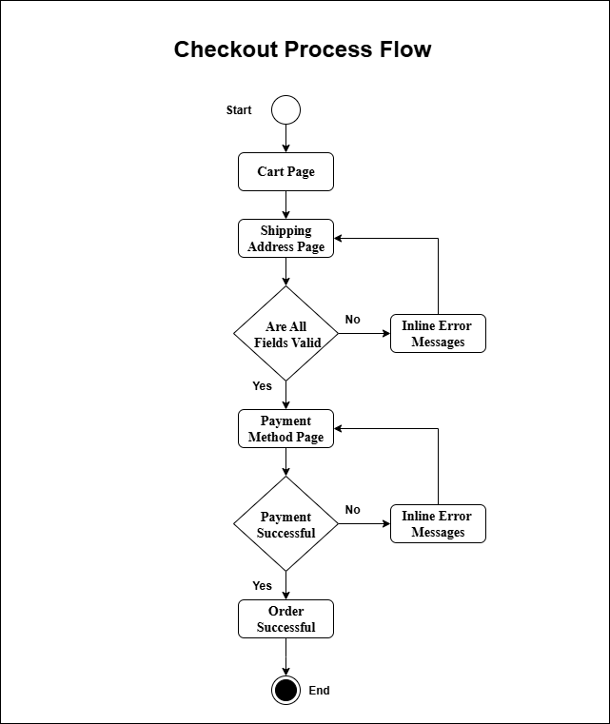

Appendix 2: Cart Page

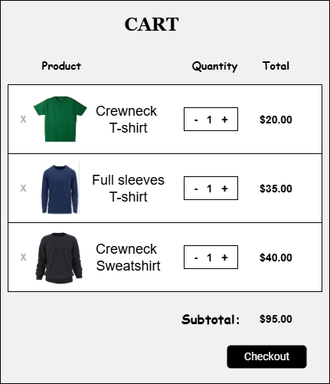

Appendix 3: Cart Page Data Table
Field Name | Field Type | Required | Content | Description
Product Name | Text | Yes | Text | Name of the product in the cart
Quantity | Number | Yes | Number | Number of units selected
Price | Currency | Yes | Currency | Price per unit of product
Total Price | Currency | Yes | Currency | Calculated total for that product
Checkout Button | Button | Yes | Button | Navigates to the Shipping Address page

Appendix 4: Shipping Address Page

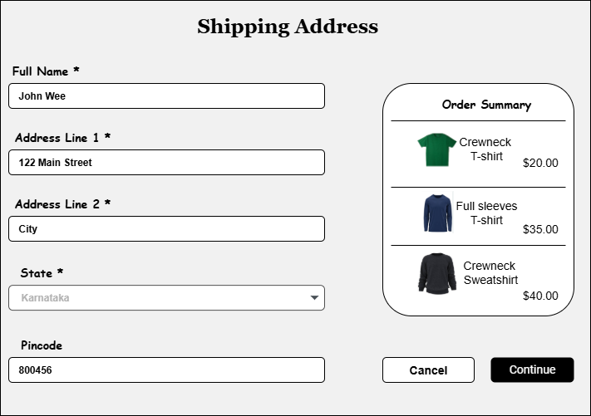
Appendix 5: Shipping Address Page Data Table
Field Name | Field Type | Required | Content | Description
Full Name | Text | Yes | Text | Recipient's name
Address Line 1 | Text | Yes | Text | Primary address line
Address Line 2 | Text | No | Text | Additional address information
City | Text | Yes | Text | City of delivery
State | Dropdown | Yes | Dropdown | Select from state list
Pincode | Number | Yes | Number | Postal code
Phone | Number | Yes | Number | Contact number
Cancel Button | Button | Yes | Button | Returns to cart
Continue Button | Button | Yes | Button | Proceeds to payment method page

Appendix 6: Payment Method Page
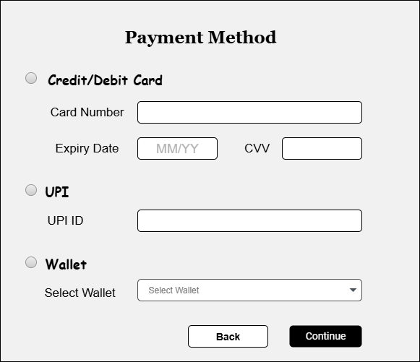

Appendix 7: Payment Method Data Table

Field Name | Field Type | Required | Content | Description
Credit/Debit Card | Radio Option | Yes | Radio | Select to pay via card
Card Number | Text | Yes | Text | 16-digit card number
Expiry Date | Text | Yes | Text | MM/YY format
CVV | Text | Yes | Text | 3-digit code
UPI | Radio Option | Yes | Radio | Select to pay via UPI
UPI ID | Text | Yes | Text | UPI payment ID
Wallet | Radio Option | No | Radio | Select to pay via wallet
Select Wallet | Dropdown | No | Dropdown | Choose wallet provider
Back Button | Button | Yes | Button | Returns to shipping page
Continue Button | Button | Yes | Button | Proceeds to order confirmation

Appendix 8: Order Successful Page
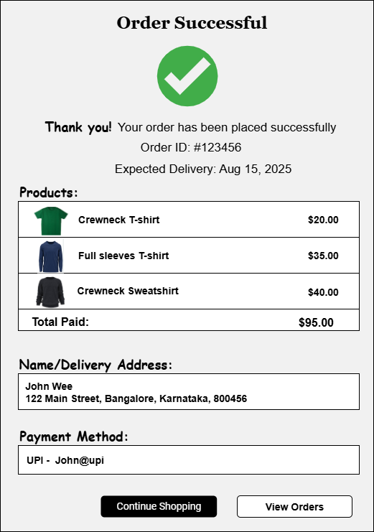

Appendix 9: Order Successful Data Table

Field Name | Field Type | Required | Content | Description
Success Icon | Image | Yes | Image | Indicates order placed successfully
Order Message | Text | Yes | Text | Thank you message
Order ID | Text | Yes | Text | Unique order number
Expected Delivery | Date | Yes | Date | Estimated delivery date
Products Table | Table | Yes | Table | Purchased products with details
Total Paid | Currency | Yes | Currency | Order total
Delivery Address | Text | Yes | Text | Full address
Payment Method | Text | Yes | Text | e.g., UPI - john@upi
Continue Shopping | Button | No | Button | Returns to store
View Orders | Button | No | Button | Goes to order history

Appendix 10: Inline Error Messages
Failed Validation | Error Message Displayed
Full Name (Shipping Address) | “Full Name is required.”
Address (Shipping Address) | “Address is required.”
Pin code (Shipping Address) | “Enter a valid 6-digit Pin code.”
State (Shipping Address) | “Please select a State.”
Card Number (Payment Method) | “Enter a valid Card Number.”
Expiry Date (Payment Method)
  “Enter a valid Expiry Date (MM/YY).”
CVV (Payment Method)
  “Enter a valid CVV.”
UPI ID (Payment Method)
  “Enter a valid UPI ID.”
Wallet (Payment Method) | “Wallet authentication failed.”

Questions to be asked to SMEs
• What are the required fields on the cart page?
• Should the cart allow quantity modification for each product?
• What validations are needed for the shipping address form?
• Which payment methods should be supported?
• Should payment details be stored for future orders?
• What information should be displayed on the order success page?
• Are there any compliance or security requirements for payment information?

